**INSTRUCTIONS TO AUTHORS FOR THE PREPARATION OF MANUSCRIPTS FOR WORLD MINING CONGRESS 2026**

*A.A. Surname1, B.B. Surname2, C.C. Surname3, D.D. Surname1

1Department of Mining Engineering, X University, Y Country,

(*Presenting author: aasurname@XX.YY)

2Mining Technology XX, YY

3Mining Division, ZZ, RR

The paper should address the main conference theme: we face a global challenge: how to deliver the minerals the world urgently needs, faster, smarter and more responsible. The World Mining Congress in Peru is a call to action for governments, industry, investors and innovators to step out of our collective comfort zones, challenge the status quo, and build trust with society.

Commercials or selling of specific products are not acceptable. If you want to showcase a product, please focus on the scientific or engineering contribution and make sure all claims are documented properly. Remove any product name or trademarked product. Instead, we encourage teaming up with a mining company to make your contribution relevant to this challenge.

**ABSTRACT**

The body of the abstract, not to exceed **350 words** in length, in regular **10-point** **Times New Roman** , fully justified, separated from the heading **ABSTRACT** by one (1) blank line and indented. The abstract is a single paragraph.

**KEYWORDS**

Instructions, authors, World Mining Congress

**1. FIRST LEVEL HEADING CENTRED**

Your manuscript must be submitted to our online submission portal **starting November 15, 2025**, instruction will be sent before that date. Manuscript should be between 2 (extended abstract) and less than **10 pages** in length, including text, figures, tables, and references.

Authors are responsible for **ensuring the accuracy of all information contained in their manuscripts** (e.g., proper names of organizations, data and findings, references, etc.).

Manuscripts must be prepared in proper English. **SI units** or **acceptable metric equivalents** must be used throughout. For Spanish speakers, we encourage you to use online translation tools, such as google translate, then proof-read the English version.

**2. PREPARATION OF THE MANUSCRIPT**

Good practice in writing technical papers should have the following content

* Scope: what topic of the conference theme are you addressing?
* State-of-the-art: what is currently being done?
* Improvement: what is lacking that needs critical innovation?
* What specifically are you contributing to the conference theme?
* What methods are you using?
* What are the results, possibly in comparison with what has been done before?
* Document any statements with tables & figures.
* Avoid making undocumented statements or opinions.

Prepare your manuscript using Microsoft (MS) Word for Windows as your word processing software. To ensure that your manuscript has an identical appearance when viewed on almost any computer, avoid the use of a two-byte code for Chinese characters, etc.

Text paragraphs are **single-spaced** (line height of 6 lines per inch) and fully justified, with the **first line indented 1.27 cm (0.5 inch)**. Paragraphs are separated with a blank line.

**2.1 Second Level Heading to the Left**

Your manuscript must be prepared in **A4-size (210 x 297 mm) paper**. Use the margin settings specified in Table 1 and do not number the pages of the paper.

Table 1 – Manuscript margins

|  |  |
| --- | --- |
| Margin | A4 (210 x 297 mm) |
| Top | 2.90 cm (1.14 inches) |
| Bottom | 4.60 cm (1.81 inches) |
| Left | 2.90 cm (1.14 inches) |
| Right | 2.90 cm (1.14 inches) |

2.1.1 Third-Level Heading Left

**Equations**

Simple mathematical expressions and sub- and super-scripted characters, such as **SO42-**, are inserted in the text. Do not embed equations as an image.

Equations are placed on separate lines, centred and numbered consecutively in parentheses at the right-hand margin. A blank line precedes and follows each equation.

**Figures**

All figures should be high resolution **(300 dpi)** when published at 100%. Figures including graphs, line drawings, photographs and other illustrations are preferably in colour. Any greyscale figures require sharp contrast. For all figures, lines and lettering must be large enough **(minimum 0.35 point thickness)** to remain clearly legible when printed at 100%. For maps, microstructures and similar figures, be sure to place a scale marker on the picture or photograph. Do not use frames around figures. Do not use shaded backgrounds as they do not reproduce well.

All figures must be consecutively numbered with Arabic numerals and inserted as close as possible to the corresponding text. A caption consisting of the word “Figure,” the figure number, a dash and the figure title, in **10-point Times New Roman**, must appear centered below each figure. A single blank line is used to separate a figure from its caption.

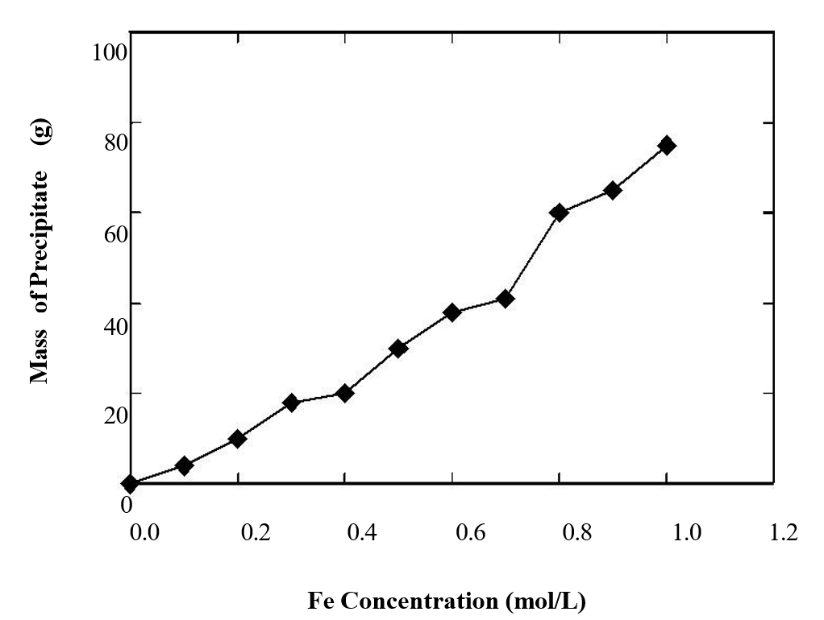

Figure 1 – Effect of iron concentration on the amount of precipitate formed during hydrolytic

precipitation from waste processing solutions

**Tables**

Insert tables as close as possible to their first citation. Number tables consecutively using Arabic numerals and centre the title above the table. The word “Table” is followed by the table number, a dash, and the rest of the title. There is no line space between the title and the table itself.

Table-wide lines **(horizontal ½ point thickness)** separate the title from the column headings, the column headings from the body of the table, and the table from the following text. Do not use vertical lines and avoid the use of horizontal lines between the various rows of data. Separate each table from the adjacent text with one (1) blank line.

**Table 2** – Electron microprobe analyses of sphalerite grains in the Kidd Creek “C” concentrate

|  |  |  |
| --- | --- | --- |
| Element | Average Content | Range |
|  | (wt %) | (wt%) |
| Zn | 60.8 | 59.6 – 63.3 |
| Fe | 5.82 | 3.54 – 6.95 |
| Cd | 0.30 | 0.12 – 0.42 |
| S | 3.31 | 33.6 – 33.5 |

**ACKNOWLEDGEMENTS**

The authors can express their appreciation or acknowledge the support and help they received for their work.

**REFERENCES**

American Psychological Association (2009). *Publication Manual of the American Psychological Association (6th ed.)*. Washington, DC: Author.

Guo, H., Todhunter, C., Qu, Q. and Qin, Z., (2015). Longwall horizontal gas drainage through goaf pressure control. *International Journal of Coal Geology*. 150-151, 276-286.